**Peru Journey**

**Shifting with the Stars**

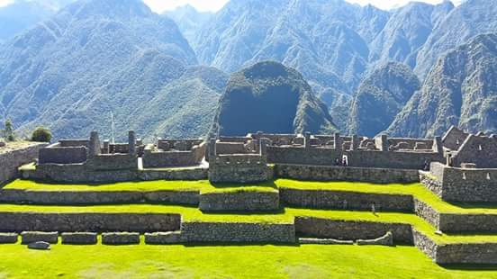

The time is approaching for balance, change and shifts. Peru is one of the most precious places to embark on allowing yourself to relax, regroup, and go within. Give yourself the gift of a lifetime, the ultimate on your bucket list. Machu Picchu is one of the Seven Wonders of the World. Remind yourself about what a wonderful life this is.

**We will make decisions on reservations for 2021 after February 2021. This will be based on current border restrictions or openings, and Covid 19 Updates then.**

**DAY 1** We invite you to join us on a very private retreat with attention to all details and experiences. First, fly to Lima, and then come to Cusco and arrive at the Cusco airport **at 11:00 AM.** We will travel by private transport to Urubamba Sacred Valley and the route will pass some small villages like Poroy, Chinchero, and the great expanse of the Sacred Valley grabbing a stop at the Mirador de Urubamba to observe the large snowy mountains of Sawasiray and Chicon Mountains. We descend to the entrance to the Urubamba Valley and towards a spacious retreat in the Valley. This place is very beautiful, with incredible attention to our passengers.  As we arrive at the hotel, we will have lunch and then we will meet to discuss our travel for the first 6 days. You will enjoy meeting a Qero elder who will share an opening ceremony. We will wander and enjoy a small tour in the hotel and ask the hotel about the healing and ceremonial areas.

**DAY 2** Travel by bus to **Chinchero** and learn their cultures and their weavings while you watch a demonstration of washing wool with natural roots and using natural dyes.  We continue the journey to Moray and the wonderful terraces and earth to connect with the pachamama.  We will feel healing energy in the center and we will be accompanied by Qero and do a ceremony on the first level.   The Qero will make an offering creating a mandala with kintus of flowers, leaves, beans, grains, and candy to the pachamama. After we are visiting Moray we return to our hotel to relax and possibly receive sessions or massage.

**DAY 3 Pisaq** – We will travel through the sacred valley by private transport, and arrive up at the Templos de Pisaq. First we wander towards to Ancient Archaeological areas and explore. Here we honor our ancestors in a short ceremony, and then continue towards the Pachamama Cave. We connect ourselves to the sweet energy and nourishment of this area, and then wander towards the main temples that many visitors miss. We explore the Temple of the Sun, and the Temple of the Waters here. We sense the energies of the Masculine and the Feminine here, and identify which of those aspects to work with in the next few days. We walk back towards our bus, and go down to the Plaza de Pisaq for a late lunch nearby.

**DAY 4** – We travel towards **Ollantaytambo**, and tour this sacred site. We sense the energies of the Wiracocha Apu across the way. We will work with the Flight of the Condor near Apu Veronica. This afternoon we travel by train to Machu Picchu, the Crystal City of Light. You will stay in the hotel room with a mini duffel, and enjoy the town of Aquas Calientes. Your bigger luggage will be stored. You may choose to visit the hot springs, and share a delicious dinner at Indio Feliz, one of the best restaurants in Aguas Calientes! Overnight in Aquas Calientes.

**DAY 5** - Rise and shine in **Machu Picchu**. We will have an early start in Machu Picchu, and explore the magic and mystery of this place. We will be with a local guide joining Jamee as we wander this amazing spot. We hike upwards to look down on the Crystal City and get our first fotos. Then we continue towards the main terraces, and around the Sun Temple, the Quarry, and the Main Plaza for ancient ceremonies. You will enjoy a guided tour of Machu Picchu and the Sun Temple, the Priest's House , the Temple of Three Windows , the Plaza de Armas. After the tour, Jamee will share with you an ancient ceremony to renew your lives and energies. We will sit in meditation on the terraces and enjoy visiting the alpacas jumping from terrace to terrace.

Here we will discover the Feminine Temple. We continue towards the Pachamama Stone, and the Condor Temple. We take a late afternoon train back to Ollantay, and then continue towards Cusco. Overnight in Cusco.

**DAY 6 -** We prepare to explore the temples and sites above Cusco, Sacsayhuaman. Sacsayhuaman has very large stones in the shape of a lightning bolt. Our local Peruvian guide will explain historical and interesting stories. We have a city tour, with the option for the Korikancha. Wander in Cusco for artisan markets and tiendas for your gifts. Peruvian Guide that speaks English will add some of the archaeological and historical pieces. Overnight in Cusco Hotel. Evening dinner celebration in delicious Cusco restaurant!

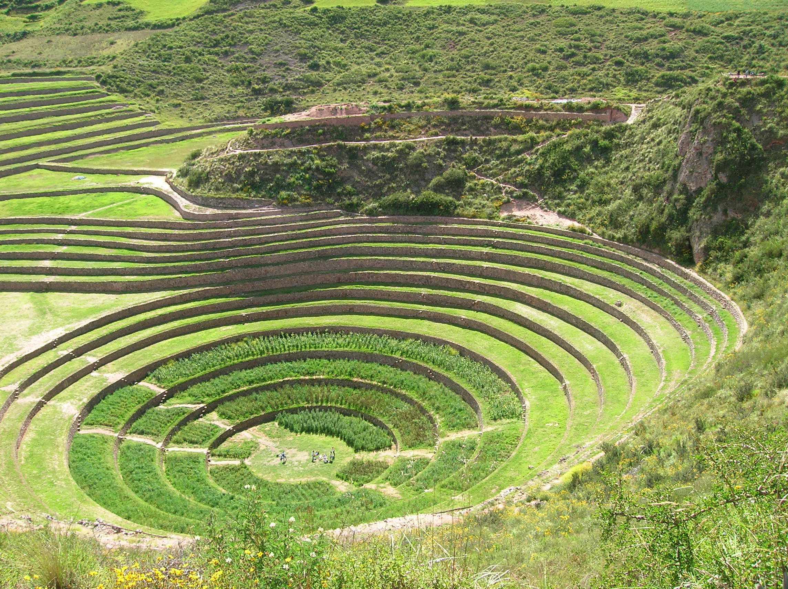

**Moray, Sacred Site**

**Lake Titicaca, Peru**

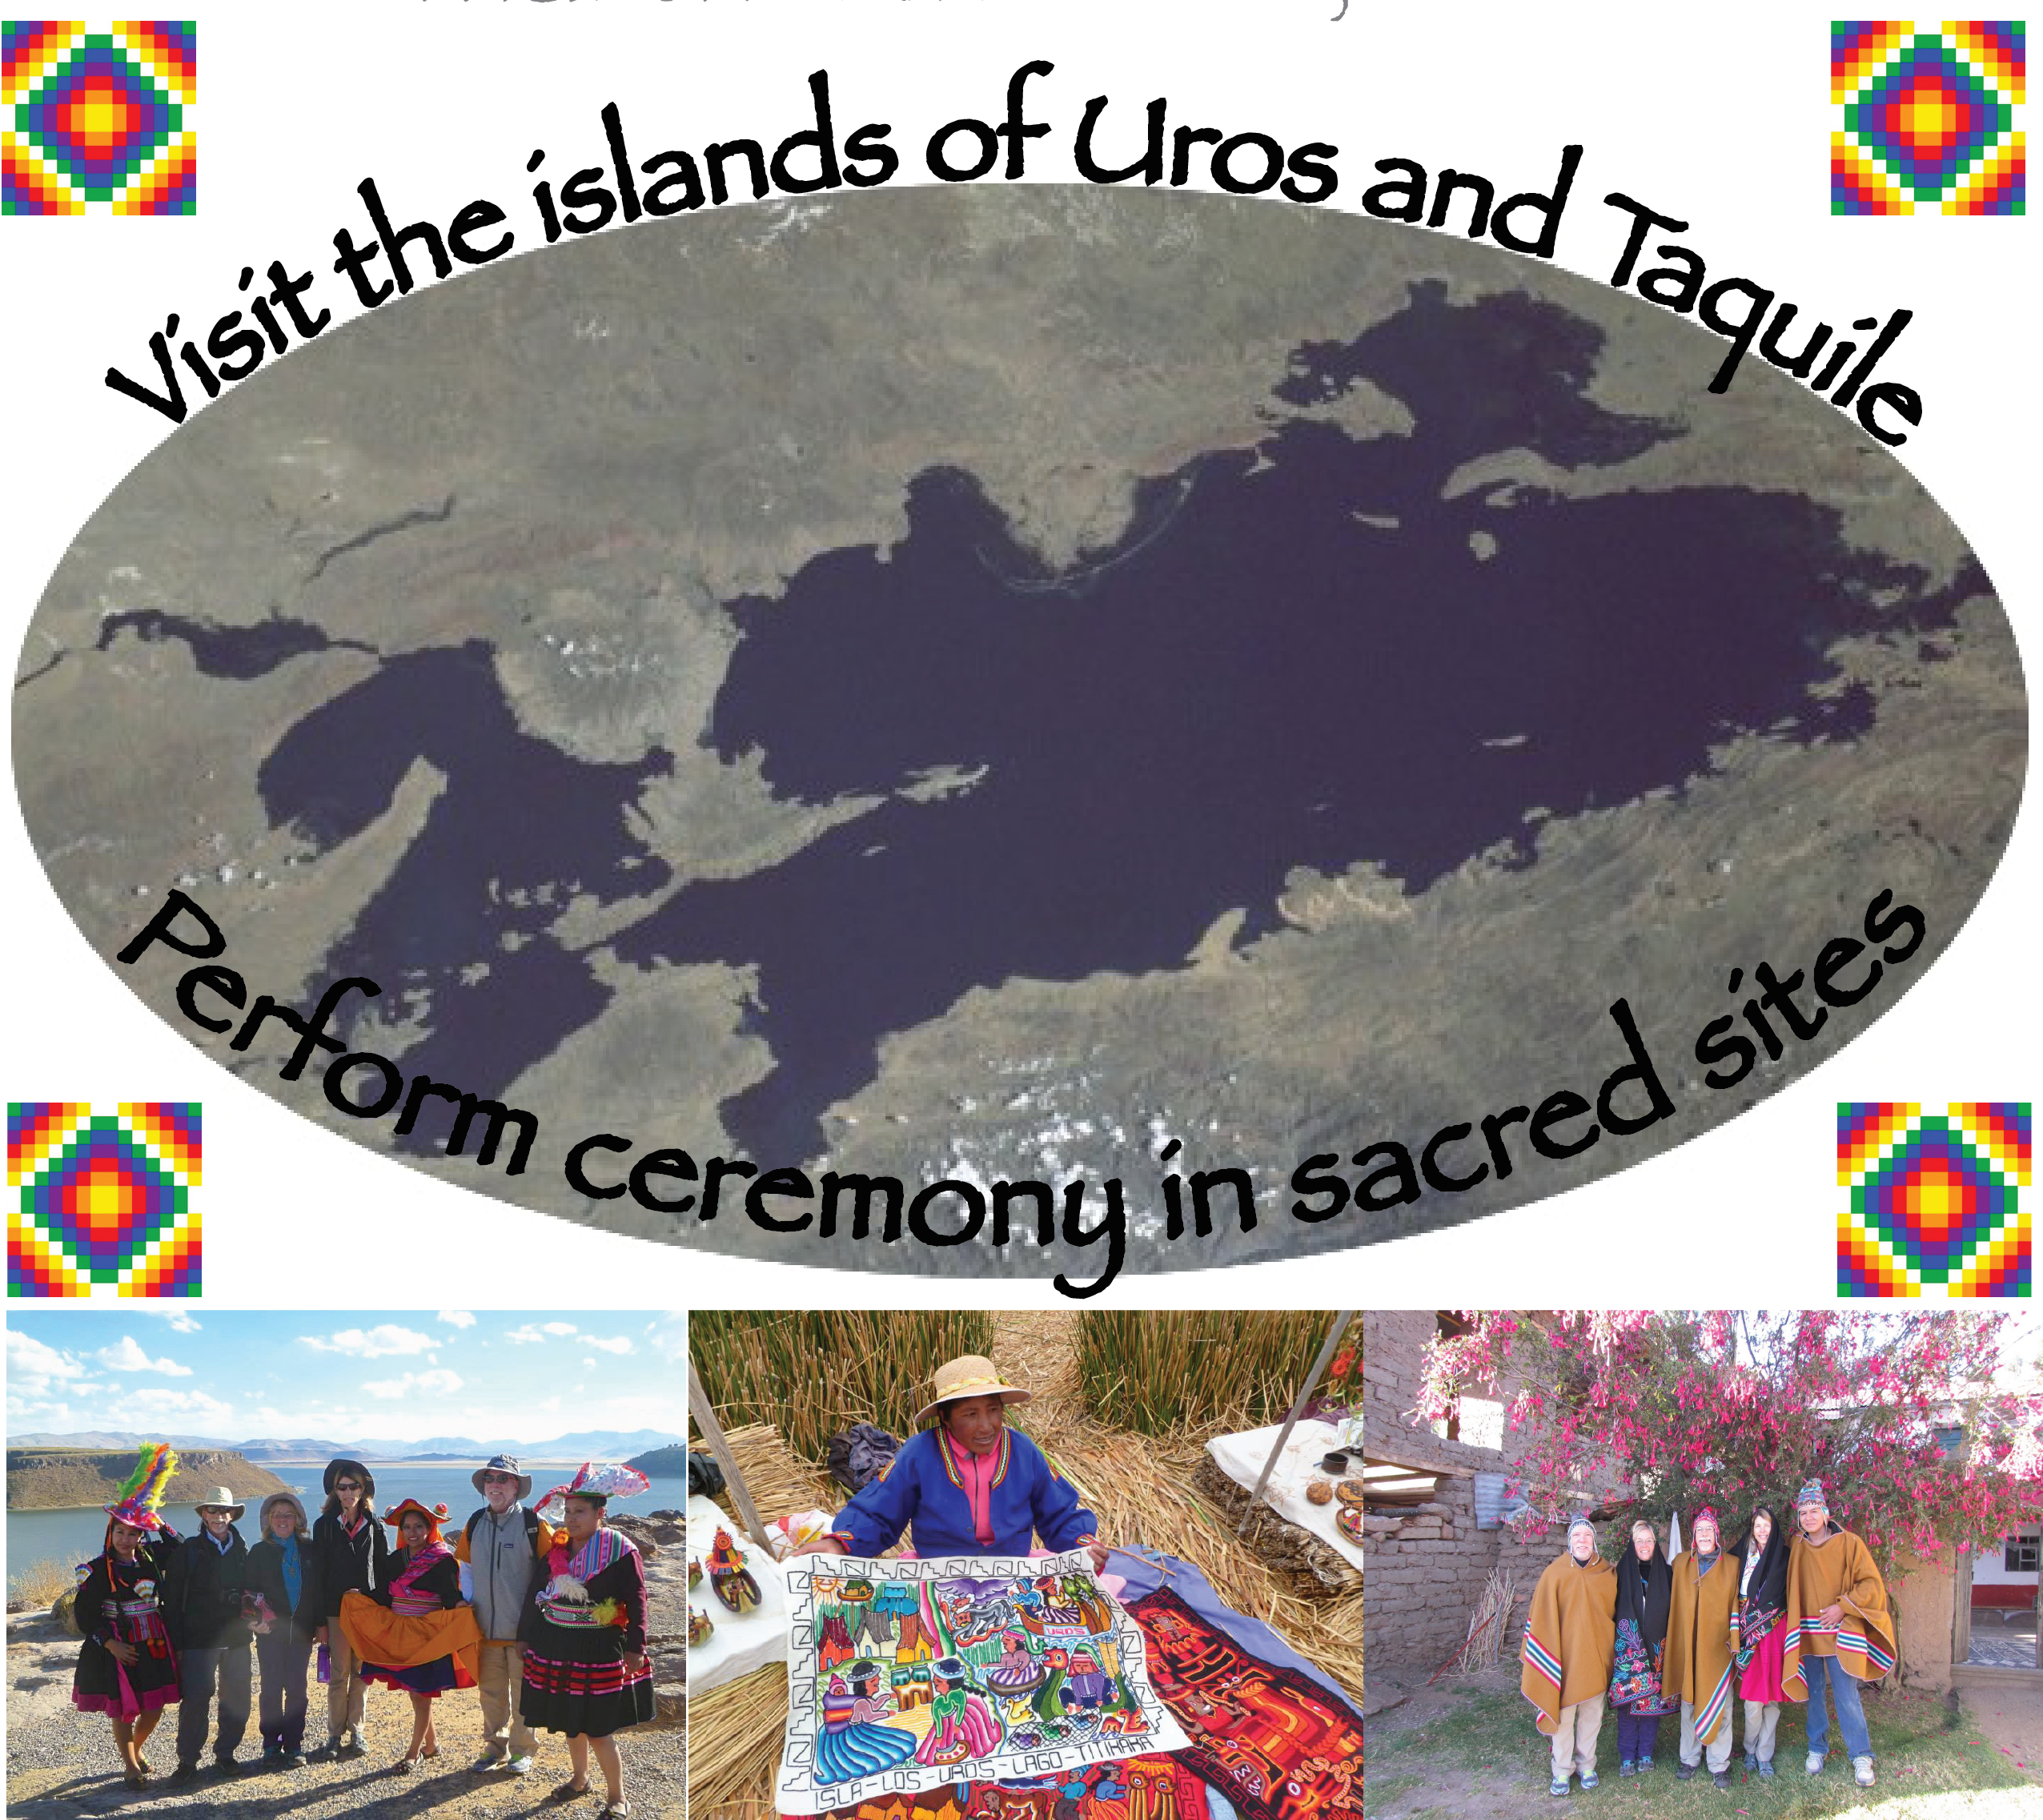

**DAY 7 –** Wetravel by bus transport towards Lake Titicaca. The bus trip includes stops to visit the sites at Racqchi, Sicuani Buffet, La Raya, and the Pucara Museum. Be sure to bring your camera. Relax in the afternoon in our beautiful hotel with crystal garden and labyrinth outside. Visit to the Templo de Fertilidad for connection to the Masculine. Overnight outside of Puno.

**DAY 8** – In themorning we travel to the islands of **Uros and Taquile** with Peruvian guide and Jamee Curtice. Watch the demonstrations of how to build a reed island, embroidered textiles, and you will be touched by the simplicity of their lives floating on Lake Titicaca. Continue to explore Taquile quiet and serene island.

**DAY 8 Continued -** We hike to the plaza and witness amazingly beautiful weavings and textiles filled with ancient symbols and artistry. We enjoy a lunch with a view of the Lake either fish or an omelete for vegetarians. We will search for the Masculine qualities on this island in their weavings. Peruvian guide and Jamee share the secrets of this amazing place. Bring extra soles here because you may want to purchase some of these amazing textiles. Return by boat to Puno in the late afternoon. We will share with an evening ceremony. Ceremony. Overnight at our hotel outside of Puno.



**DAY 10** - Travel to **Aramu Muru Portal** for Ceremony. Enjoy a day of gentle hiking in the area and ceremonies working with all the sacred rays. Connect to the place of the Inti offerings, the Jaguar Paws, and the Place of Calling. We will be Activating the Solar Disk internally and externally in this ancient place. This is an excellent location for some of you to lead us in a ceremony, also. Evening Option: Labyrinth Walk and Fire Ceremony.

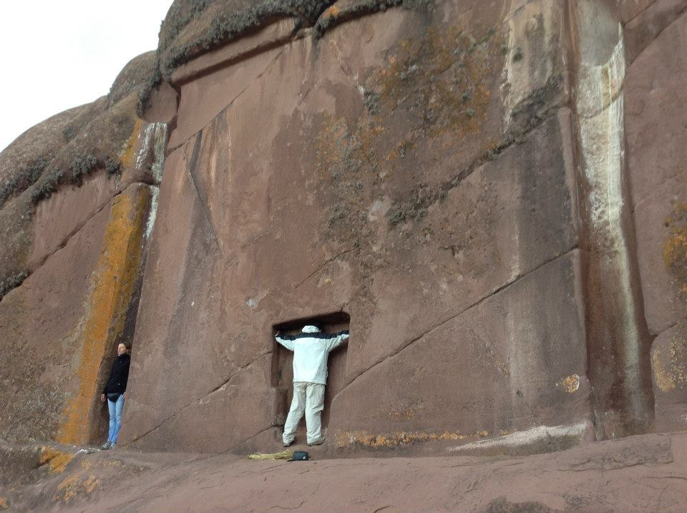

**DAY 11** – Travel to the airport of **JULIACA, PERU** to fly to Lima, Peru for your late night departure to your country. ( You do not return to Cusco, so we travel about an hour and a half to the airport of Juliaca for your LATAM airlines flight to Lima. )

**Latam Airlines leaves at:**

**1:20p - 2:55p**

1h 35m

JUL - LIM

Nonstop

**LATAM Airlines Group 2096 operated by Latam Airlines Peru**

**Costs: 4 – 12 People - $4550 includes lodging, transportation, and guiding in shamanic practices for 11 Day Journey. Cost is $2950 for 6 Day Valley and MAPI Journey.**

**Non Refundable Deposit is $1500.00 after February 2021. This reserves your spot for the journey. Balance of $3050 is due by 3 months ahead.**

**Option Deposit and Final Balance ***** After March 1st payments will be completed through paypal. Send me your paypal email.**

WHATS INCLUDED:

* Guiding and teachings of the Andean Traditions
* Mesa Processes and Initiations
* Private Transport to all Lodging in the Sacred Valley
* Breakfasts
* Qero Ceremonies
* Entrance to Machu Picchu and Train
* Boleto Turistico

 

WHATS NOT INCLUDED:

* Lunches and Dinners during the First Week
* Tips for Staff (We recommend saving $10 dollars per day for a total of $120 that I will use for bus drivers, translators, assistants, etc... )
* Gifts: The Qero will be offering their textiles for sale when they come.
* Private Healing Sessions (Bring $60 for private despachos and $100 for personal healing sessions )
* Shopping in the Tiendas (There are many local artisan areas that we will visit )

DETAILS:

You MUST purchase travel insurance from an excellent company such as CSA or Travelex, which will assist you if you have to cancel your tour for medical reasons or require medical assistance or medical evacuation. Most travel insurances ask you to purchase this **within several weeks of your initial deposit.**

We email you a What to Bring List, and a Release of Risk Form, and a Contact Traveler Information Form after you make your first deposit of $1500. This deposit is NON REFUNDABLE.

In order to purchase your Machu Picchu Train and Entrance tickets we must have a scanned updated passport and your paid deposit. Hotels require the passport also to reserve your spot. *****

You want to begin a nice gentle hiking preparation program... walking for at least an hour several times a week, and if possible gentle hiking in some altitude.

Flights can be reserved online or with a travel agent. This tour does not include any flights.... Airlines that frequently fly to Lima and then to Cusco are: LATAM Airlines, TACA or AVIANCA. *** I fly on LATAM because they have many flight options.

Give yourself the gift of sacred journey for 2021 or 2022! Email me at jcheartsoul@gmail.com

**Jamee Curtice is an Energy Medicine Consultant and Teacher of the Andean Traditions. She has lead groups to Peru for over 10 years. She was a Senior Teacher with the Four Winds Society Trainings, and later moved half time to Peru. She has studied with a variety of Ancient Traditions in Peru and other places. She looks forward to sharing these sites with you, and encouraging you to leap into new possibilities.**

**She teaches Energy and Shamanic Processes, and how to begin your mesa, or to strengthen the mesa you already have. She shares the Munay Ki rites and the teachings of Llankay, Munay, and Llachay. Email her directly at** jcheartsoul@gmail.com

**Travel Website:** [**www.perumisticotravels.com**](http://www.perumisticotravels.com)

